Project Title:
AI System to Automatically Review and Summarize Research Papers

Internship Program: Infosys Internship
Intern Name: Pari Purswani
Mentor: Ms. M.Likhita

- Introduction
The exponential growth of academic publications has made manual literature review increasingly complex and time-intensive. Researchers must search for relevant papers, extract key findings, compare methodologies, synthesize results, and format references — all while maintaining academic rigor and structural consistency.
This project presents an AI-driven automated system that generates structured literature reviews using a stateful graph-based workflow. The system automates the entire research review lifecycle — from paper discovery to final draft refinement — ensuring consistency, modularity, and controlled execution.
The primary objective of this system is to:
- Automate research paper retrieval based on a user-defined topic
- Extract structured content from academic PDFs
- Identify key findings across multiple papers
- Perform cross-paper comparison
- Generate structured review sections (Abstract, Methods, Results)
- Format references in APA style
- Evaluate and refine the generated draft using scoring-based quality assessment

2. System Overview
The system follows a four-phase structured workflow:
- Research Phase
- Analysis Phase
- Writing Phase
- Review Phase
Each phase is implemented as a modular node within a LangGraph-based directed workflow. The pipeline ensures controlled state transitions between stages, allowing reliable progression from search → extraction → analysis → synthesis → evaluation.
Unlike a linear script, this architecture allows dynamic skipping of failed components and controlled re-execution of specific modules.

3. Methodology / Workflow
3.1 Research Phase
This phase performs topic-based academic paper discovery and dataset preparation.
Process Flow:
- User enters a research topic through the interface
- The system queries the Semantic Scholar API
- A minimum of six research papers are retrieved
- PDFs are automatically downloaded
- Papers that contain unsupported layouts, scanned formats, or invalid structured outputs are automatically filtered out
- Only structurally valid and machine-readable papers proceed to the analysis stage
Although six papers are retrieved initially, the system dynamically processes only valid papers. This ensures robustness against:
- Scanned PDF formats
- Extraction failures
- Invalid JSON outputs
- Unsupported layouts
This design guarantees that even if some papers fail, the workflow continues with the remaining valid ones.

3.2 Analysis Phase
The analysis phase extracts structured textual content from the validated research papers.
Key Operations:
- PDF parsing using PyMuPDF4LLM
- Section-wise segmentation
- Key finding identification
- Thematic clustering
- Cross-paper comparison
The module generates structured comparison data by identifying:
- Common themes
- Methodological similarities and differences
- Result overlaps
- Unique contributions of each paper
The extracted and analyzed data is stored in structured format for downstream synthesis.

3.3 Writing Phase
In this phase, the system generates a structured literature review draft using Gemini-based large language models integrated via LangChain and LangGraph.
Generated Sections:
- Abstract (strict 100-word limit)
- Methods Comparison
- Results Synthesis
- APA-formatted References
Instead of producing isolated summaries, the system synthesizes insights across papers to generate a unified and academically coherent review.
The synthesis logic ensures:
- Cross-paper integration
- Removal of redundancy
- Logical flow across sections
- Academic tone and structure

3.4 Review Phase
The Review Phase performs automated evaluation and refinement of the generated draft.
This module introduces a scoring-based assessment framework consisting of:
- AI Score – Evaluated by the language model based on coherence, synthesis quality, and structure
- Heuristic Score – Rule-based evaluation using structural and formatting checks
- D Score – The difference between AI Score and Heuristic Score
The D Score represents the gap between semantic quality and structural compliance. A higher D Score indicates inconsistency between generated reasoning and rule-based formatting expectations.
The review module provides:
- Structured revision suggestions
- Identified improvement areas
- Quality comparison metrics
- Optional regeneration of improved draft
This scoring mechanism introduces measurable evaluation rather than relying purely on subjective output generation.

- System Architecture
4.1 Data Management and Version Control Strategy
The system implements a structured data management and version control mechanism to prevent data overwriting and ensure reproducibility. Each execution cycle generates uniquely identifiable artifacts using timestamp-based folder organization. Every research paper is assigned a unique Paper ID, and each comparison operation is assigned a distinct Comparison ID. These identifiers ensure traceability across modules and eliminate the risk of file overwriting. The timestamped directory structure maintains clear version history for extracted data, comparison outputs, generated drafts, and evaluation results, thereby enhancing auditability and workflow integrity.
4.2 Semantic Sectioning Engine (LangGraph Integration)
The system integrates LangGraph specifically for semantic sectioning during the analysis phase. LangGraph is not used to orchestrate the entire pipeline; instead, it is applied to manage structured segmentation of extracted academic content into meaningful semantic sections.
Within this component, extracted text from research papers is organized into logically defined segments to ensure consistent downstream processing. The graph structure enables controlled state transitions while maintaining contextual continuity during section-level parsing.
Key characteristics of this semantic sectioning layer include:
• Structured segmentation of extracted academic text
• Context-aware state handling during section parsing
• Modular isolation from other system components
• Controlled processing flow within the analysis stage
All other operations — including key finding extraction, cross-paper comparison, draft generation, scoring, and refinement — are implemented independently outside the LangGraph layer
This architecture provides higher reliability and maintainability compared to sequential script-based pipelines.

5. Modules Description
5.1 Paper Retrieval Module
- Integrates with Semantic Scholar API
- Retrieves minimum six papers per topic
- Downloads research PDFs
- Automatically filters unsupported or invalid documents
- Prepares validated dataset for analysis

5.2 Text Extraction Module
- Uses PyMuPDF4LLM for PDF parsing
- Performs section-wise segmentation
- Converts academic text into structured format
- Handles extraction failures gracefully

5.3 Analysis Module
- Extracts key findings from each paper
- Performs cross-paper thematic comparison
- Identifies overlaps and distinctions
- Generates structured comparison outputs

5.4 Draft Generation Module
- Uses Gemini API via LangChain integration
- Generates:
  - Abstract (100-word constraint enforced)
  - Methods comparison
  - Results synthesis
- Formats references in APA style
- Ensures cross-paper synthesis rather than isolated summarization

5.5 Review & Refinement Module
- Computes AI Score
- Computes Heuristic Score
- Calculates D Score (gap metric)
- Generates revision suggestions
- Supports regeneration cycle
- Produces final refined draft
This module transforms the system from a simple generator into an evaluative pipeline.

6. Week-wise Implementation
Week 1–2
- Environment setup
- Dependency configuration
- Semantic Scholar API integration
- Automated PDF retrieval
Week 3–4
- PDF extraction module implementation
- Section segmentation
- Key finding extraction logic
- Cross-paper comparison system
Week 5–6
- Gemini API integration
- Structured draft generation
- Cross-paper synthesis logic
- APA formatting implementation
Week 7–8
- Review and scoring framework
- D Score computation
- Regeneration mechanism
- Gradio interface integration
- Final system testing and validation

7. Technology Stack
Programming Language:
Python 3.x
Libraries and Frameworks Used:
- Gradio (User Interface)
- LangChain
- LangGraph
- Gemini API
- PyMuPDF4LLM
- Pandas
- NumPy
No unused frameworks or external hubs are included in the final implementation.

8. Implementation Snapshots

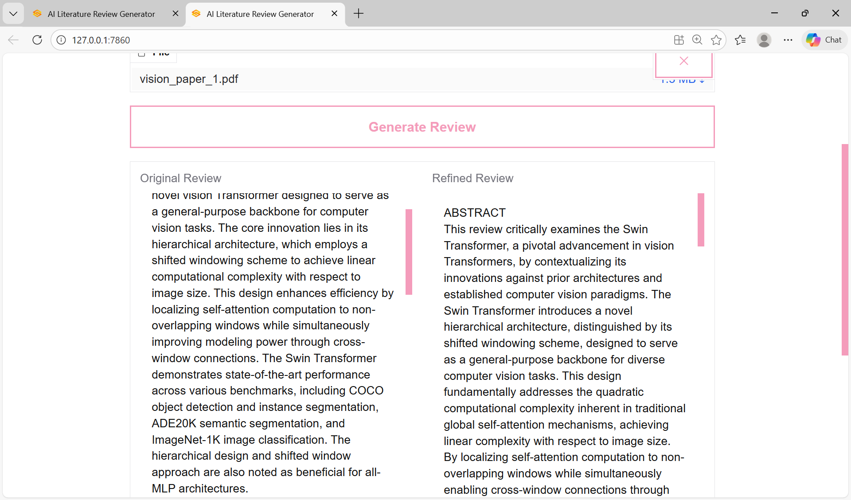
8.1 Refined Review Output Interface
This snapshot displays the structured literature review generated by the system, including the Abstract, Methods Comparison, Results Synthesis, and APA-formatted References. It also demonstrates the user-triggered refinement function.

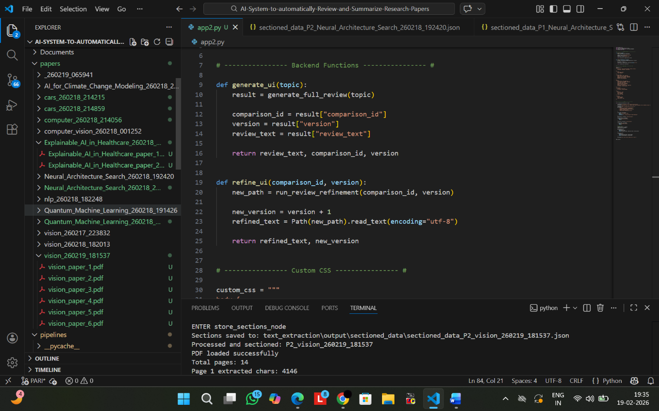
8.2 Modular Architecture and Timestamped Version Control
This snapshot illustrates the organized project structure, including modular code separation, timestamp-based folder generation, unique Paper IDs, and Comparison IDs. The structured directory layout ensures traceability, prevents overwriting, and maintains execution-level version control

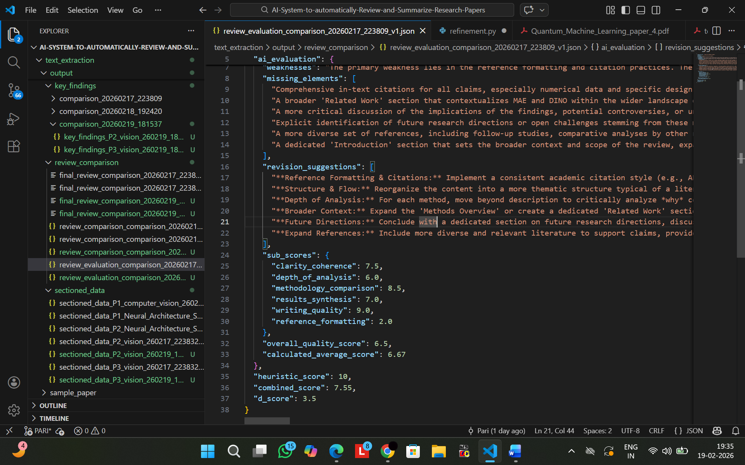
8.3 Review Evaluation and Scoring Metrics
This snapshot presents the automated evaluation framework used to assess draft quality. It displays the AI Score, Heuristic Score, Combined Score (if applicable), and D Score, which measures the gap between semantic quality and rule-based structural compliance

